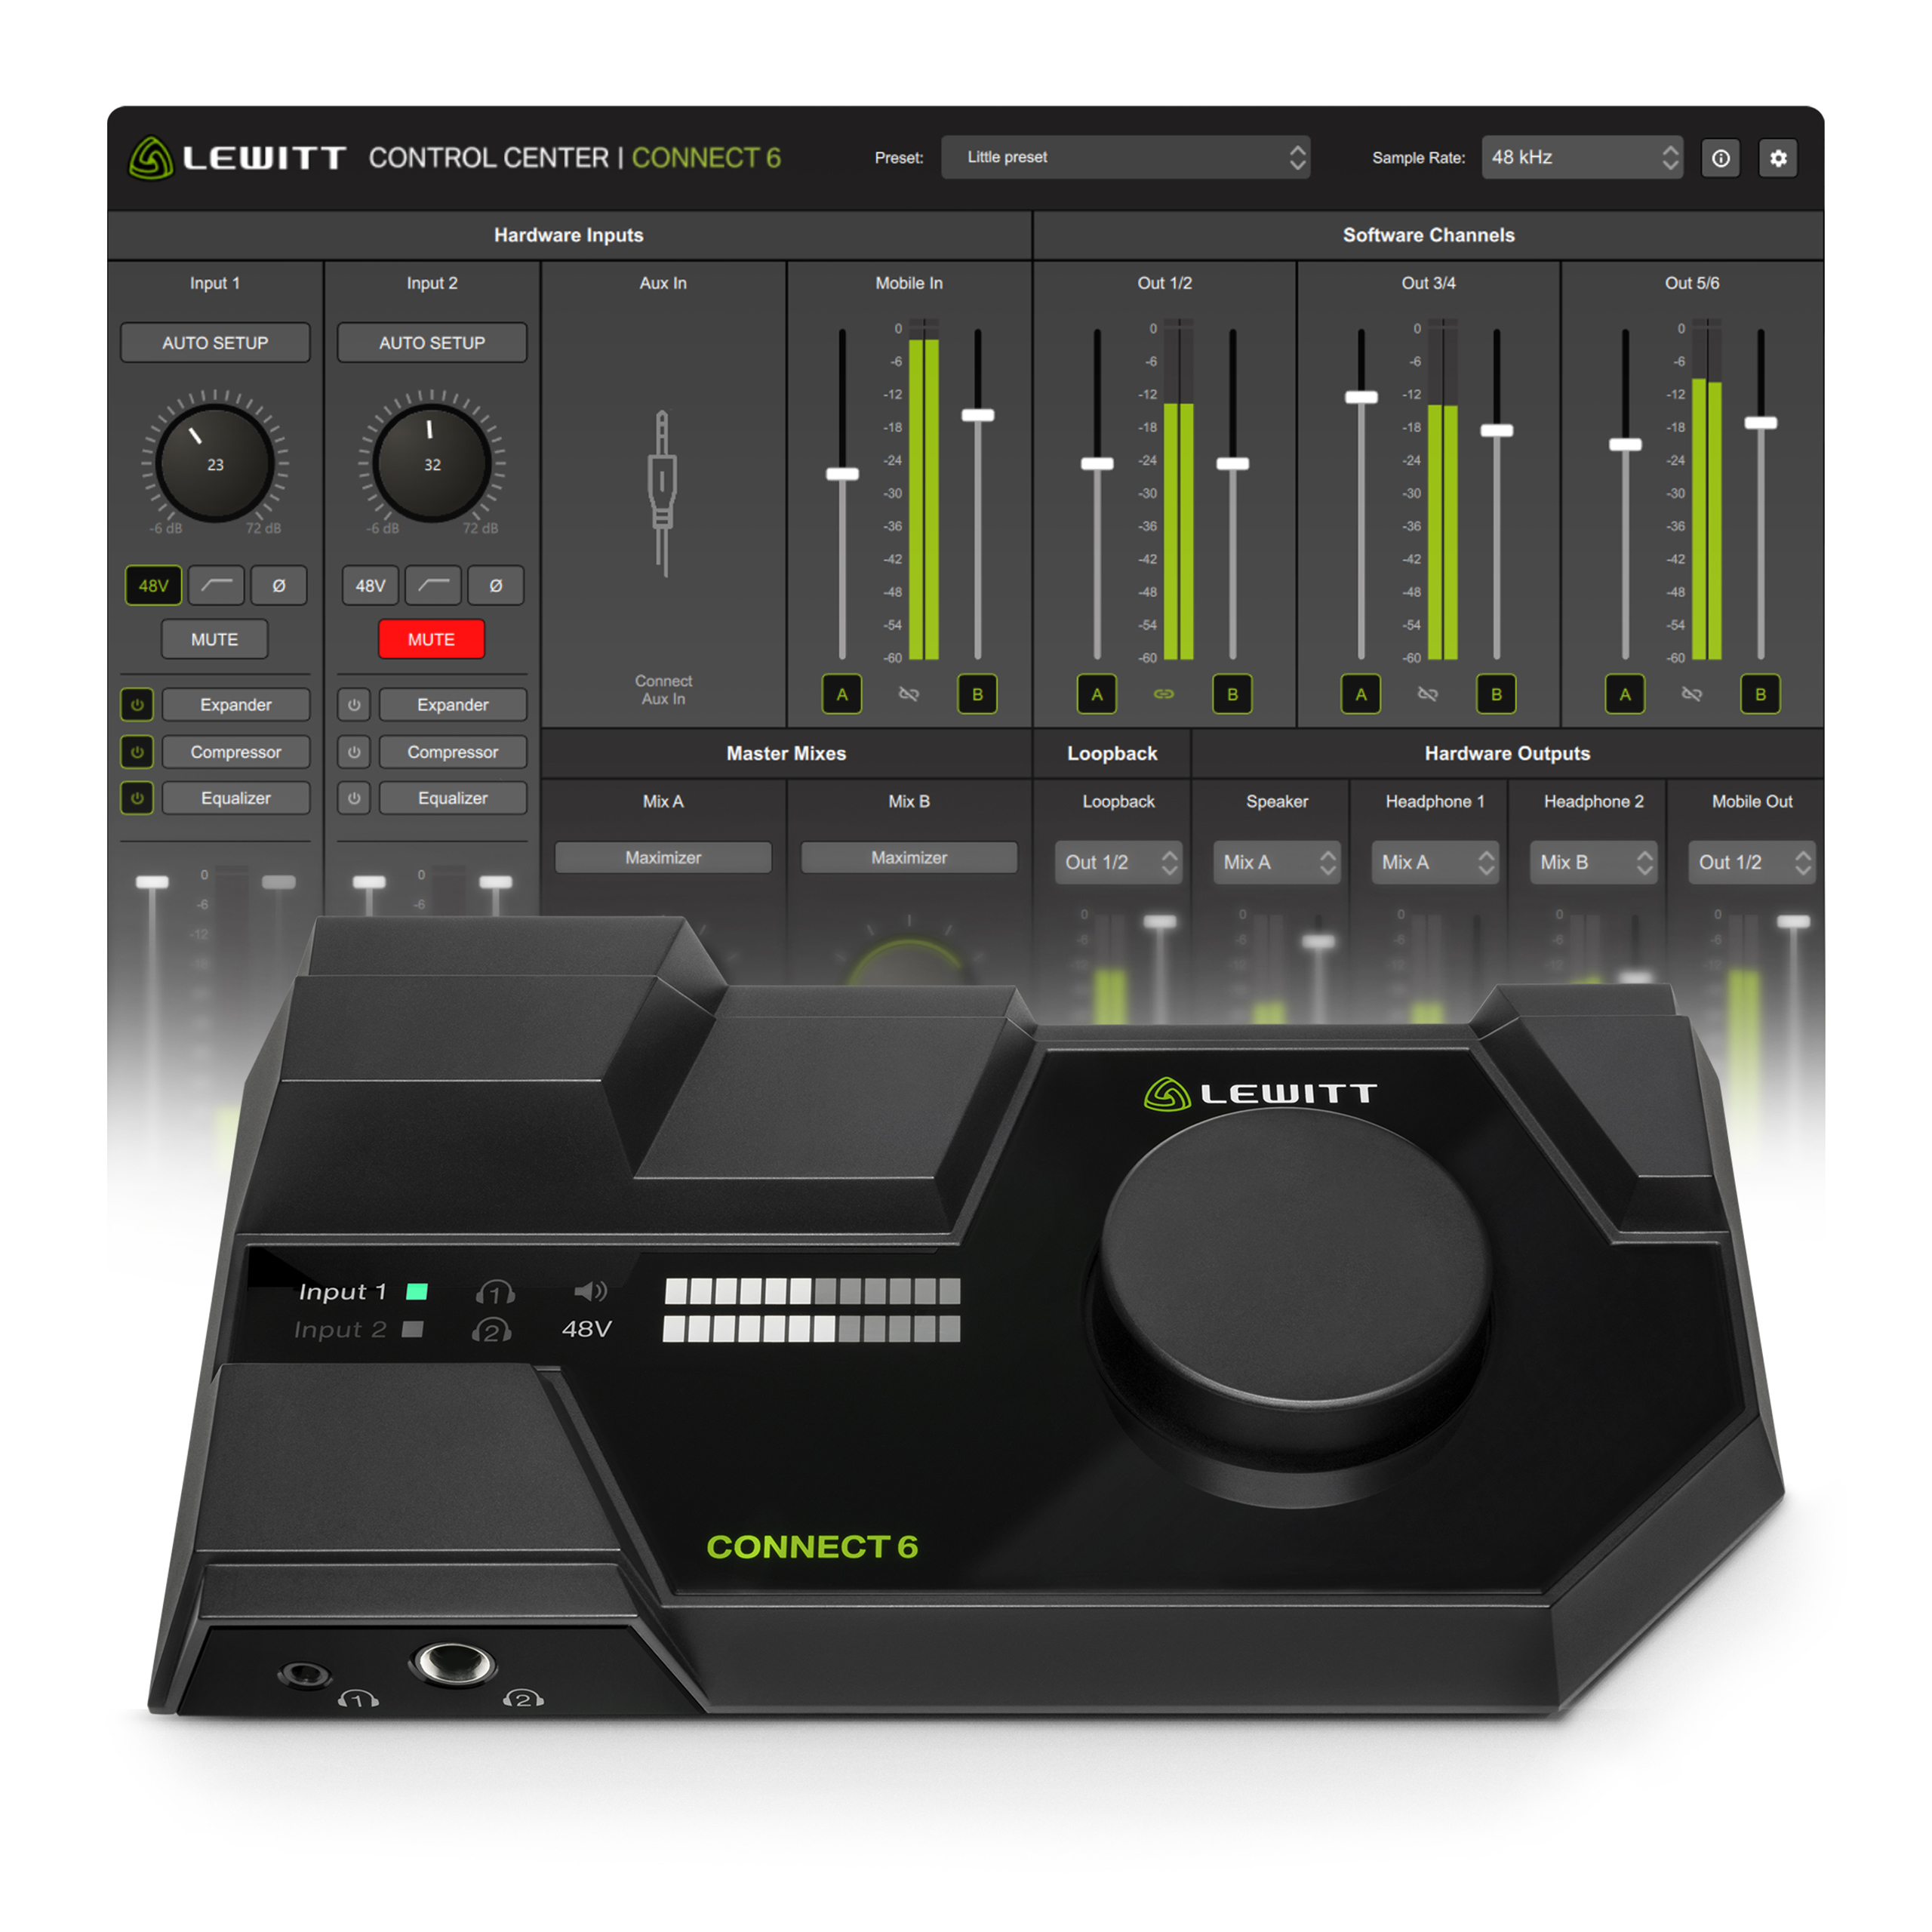
CONNECT 6

Audio interface for

game-changing flexibility.

Brand name: LEWITT

Product name: CONNECT 6

SRP: 299 €/$

SKU Code: CONNECT6

One-line description
CONNECT 6 is a DSP-powered Dual USB-C audio interface with game-changing flexibility for creators and musicians.

Short description
CONNECT 6 is a Dual USB-C audio interface with game-changing flexibility for creators and musicians. It features extensive analog and digital connectivity, full iOS/Android device integration, and crystal-clear sounding studio-grade preamps. The onboard DSP effects provide fantastic sound for vocals and instruments with zero-latency. Auto Setup helps to find your optimal settings automatically. The included CONTROL CENTER software offers virtual channels, a mixer, loopback, and individual audio routing. You can set up workflows from basic to complex easily. Since your audio is processed via the hardware-based DSP, your setup is highly stable and independent of your computer’s performance. Everything is conveniently managed on a single device—no more workarounds.

Features:

- Dual USB-C audio interface for creators and musicians
- 2 Crystal-clear studio-grade preamps with 72 dB gain and low-noise performance of -133 dBV EIN
- Auto Setup dials in optimal settings for your voice or instrument automatically
- Powerful hardware-based DSP for routing, mixing, zero-latency FX (Compressor, 4-band EQ, Expander, Maximizer) and monitoring
- 2 Independent headphone outputs powerful enough to drive any studio headphone (6.35 mm & 3.5 mm)
- Full mobile device audio integration with charging via USB-C (Apple MFI certified - Made for iPhone, iPad / Android)
- 2 Balanced speaker outputs (6.35 mm / 1/4 inch)
- 1 Stereo speaker out (3.5 mm / 1/8 inch)
- 1 Stereo aux input for additional audio devices (3.5 mm / 1/8 inch)
- 3 Virtual stereo channels for custom audio routing
- 1 Loopback channel to digitally record your computer’s audio
- 2 Independent master mixes with one-knob Maximizer
- ASIO driver included
- CONTROL CENTER for Mac and Windows
- Licenses for Steinberg’s Cubase LE, Cubasis LE included
- 1 USB-C to USB-C and 1 USB-C to USB-A cable included

Full description
For creators and musicians.
Today we don’t use audio interfaces only to record music anymore, but also host podcasts, take zoom calls, participate in live streams, or produce content for social media. To meet all these new requirements, CONNECT 6 extends the usability of an audio interface beyond basic recording functionalities and allows for personalized, convenient, and frictionless workflows with crystal-clear sound quality.

Finally, no more workarounds!
CONNECT 6 is a Dual USB-C audio interface with game-changing flexibility for creators and musicians.

- Extensive analog and digital connectivity
- Crystal clear studio-grade preamps with 72 dB gain and low-noise performance of -133 dBV EIN
- Auto Setup finds your optimal settings automatically
- Onboard DSP effects (expander, compressor, 4-band EQ, maximizer)
- DSP-based virtual channels, mixer, loopback
- CONTROL CENTER software for Windows and Mac
- Full iOS/Android device integration

Easily create workflows from basic to complex. Since your audio is processed via the hardware-based DSP, your setup is highly stable and independent of your computer’s performance. Everything is conveniently managed on a single device—no more workarounds.

Studio quality preamps with industry-leading low noise performance.
CONNECT 6 provides crystal-clear sound with any microphone. Both preamps come with an industry leading low noise performance of -133dBV EIN and 72 dB of gain so you can use any microphone without expensive signal boosters.

Auto Setup
Activate Auto Setup on the input channels and let CONNECT 6 find the optimal settings for your voice or instrument automatically.

Refine your sound with DSP-powered FX and zero-latency monitoring
Enjoy professional sound right from the start by adding DSP-powered effects to your voice, vocals, and instruments without introducing latency to your monitoring or using precious CPU power from your computer.

- Expander
- Compressor
- 4-band EQ
- Maximizer

Full mobile phone/tablet integration
CONNECT 6 lets you fully integrate your mobile device (or a 2nd computer) into your audio setup.

- Lossless digital audio transfer between computer and mobile device
- Charging function via USB port
- Apple MFI certified for iPhone/iPad
- Android phones/tablets

CONTROL CENTER for custom audio setups and workflows
Creating your custom audio setup and presets is super easy with the included CONTROL CENTER software. Combine the microphone signal with other audio sources from your computer, mobile device, or other inputs. You can create two completely independent audio mixes, Mix A and B. For example, Mix A could be used for personal monitoring while Mix B is being sent wherever you need it, be it your DAW, a streaming software, or a virtual meeting. You can even send your mix to applications on your mobile device. Both mix outputs feature a one-knob Maximizer to ensure that your mixes always have the optimal loudness level.

- 3 Virtual stereo channels for custom audio routing
- 1 Loopback channel to capture audio from any software, browser, game, or Zoom call.
- 2 Independent master mixes with one-knob Maximizer to ensure optimal loudness

Included software

- LEWITT CONTROL CENTER software
- Steinberg Cubase LE
- Steinberg Cubasis LE
- Compatible with Mac, PC, iPhone, iPad, and Android.

Specifications
Digital
USB-C Computer Port: USB Audio Class 2 / 44.1, 48, 96 kHz / 24 bit
USB-C Mobile Port: USB Audio Class 1 / 44.1, 48 kHz / 24 bit
Compatible with Mac, Windows, iOS, Android
ASIO driver - Yes
DSP-powered – Yes

Preamps
Connector: XLR / 6.3 mm (1/4 inch) jack combo
Phantom power: 48 V
Gain range: -6 dB – 72 dB
Frequency response: 20 Hz – 20 kHz
Equivalent input noise: -133 dBV (A-weighted)
Total harmonic distortion + noise: 0.002%

Line out L/R
Connector: 6.35 mm (1/4 inch) balanced jack, 3.5 mm (1/8 inch) stereo jack
Frequency response: 20 Hz - 20 kHz
Max output level: 13 dBV
Total harmonic distortion + noise: 0.002%

Headphone 1 & 2
Connector: Headphone out 1: 3.5 mm (1/8 inch) stereo jack, Headphone out 2: 6.3 mm (1/4 inch) stereo jack
Frequency response: 20 Hz - 20 kHz
Max output level: 6 dBV
Total harmonic distortion + noise: 0.002%

Power requirements
Bus powered USB C: Power + mobile device charging
Bus powered USB A: Power + mobile device charging (depending on USB port power) / Connect external power supply to power input for optimal performance
Recommended external power supply: USB-C PD 27W or more (not included)

Box contents
- 1 CONNECT 6 audio interface
- CONTROL CENTER software
- 1 USB-C to USB-C cable
- 1 USB-C to USB-A cable
- License for Steinberg Cubase LE & Cubasis LE

Images and other resources
Lewitt Public Share – CONNECT 6

UPC, EAN, packaging
UPC Code: 847986002242
EAN Code: 9120044043304
Gross weight: 0,88 kg
Dimensions (packaging): 267 x 201 x 54 (L x W x H mm)
Dimensions (product): 220 x 110 x 42,5 (L x W x H mm)
Weight (product): 0.405 kg

Contact us
Make yourself heard.
www.lewitt-audio.com

